05th January 2018

**YOKOHAMA to Launch “BluEarth-Van RY55”**

YOKOHAMA today unveiled the “BluEarth-Van RY55,” a new fuel-efficient tyre for vans that incorporates the Company’s advanced BluEarth tyre technology. The tyres are scheduled to go on sale gradually from March 2018, in a total of 30 sizes ranging from 225/55R17C 109/107H to 185R14C 102/100S. The tyres will be available in Europe, Asia (excluding Japan), Oceania, Latin America, Middle East, and Africa.   
  
Development of the “BluEarth-Van RY55” focused on greatly improving wear resistance but also aimed at further enhancing wet grip performance and fuel efficiency. Wear resistance and wet grip performance have been enhanced by the development of a special tread pattern. The tyre also features shoulders with deep lugs and sipes that enhance steering stability and drainage while helping to prevent uneven wear. The “BluEarth-Van RY55” is made from a new compound that includes a triple polymer to boost the tyre’s durability and resistance to uneven wear and silica to enhance fuel efficiency and wet grip performance. The new tyre also features a revised profile that provides a more optimal surface contact shape and more uniform surface contact pressure. As a result, the “BluEarth-Van RY55” is over 50% more wear resistant than the existing RY818 model. It also has a 9% shorter wet braking distance and reduces rolling resistance by 19%.   
  
BluEarth is a YOKOHAMA global tyre brand based on the concept of “environmentally, human, and socially friendly.” In addition to the “BluEarth-Van RY55,” the BluEarth brand includes the high-performance, fuel-efficient “BluEarth-A”; the fuel-efficient “BluEarth RV-02” for minivans and crossover SUVs; and the brand’s standard, fuel-efficient “BluEarth-Es ES32.”

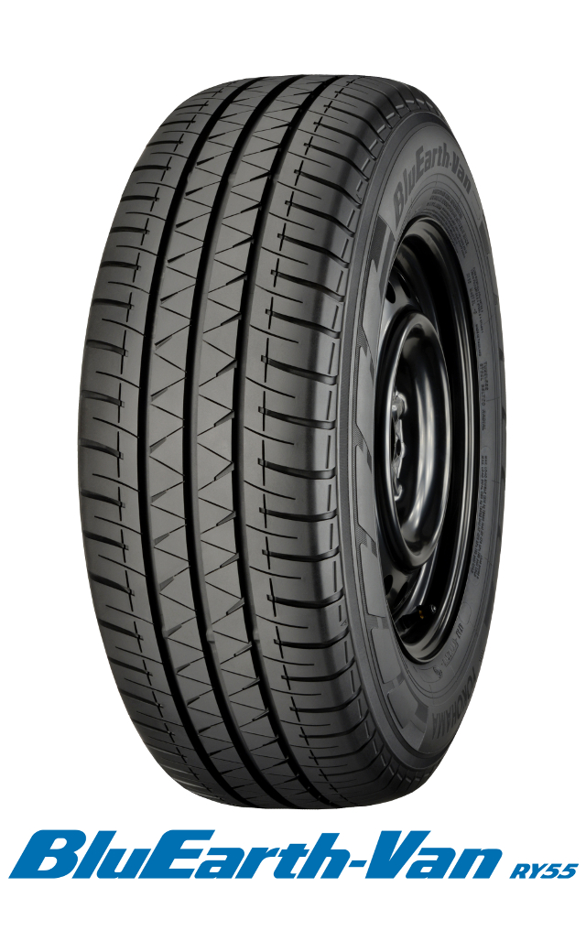

*BluEarth-Van RY55*